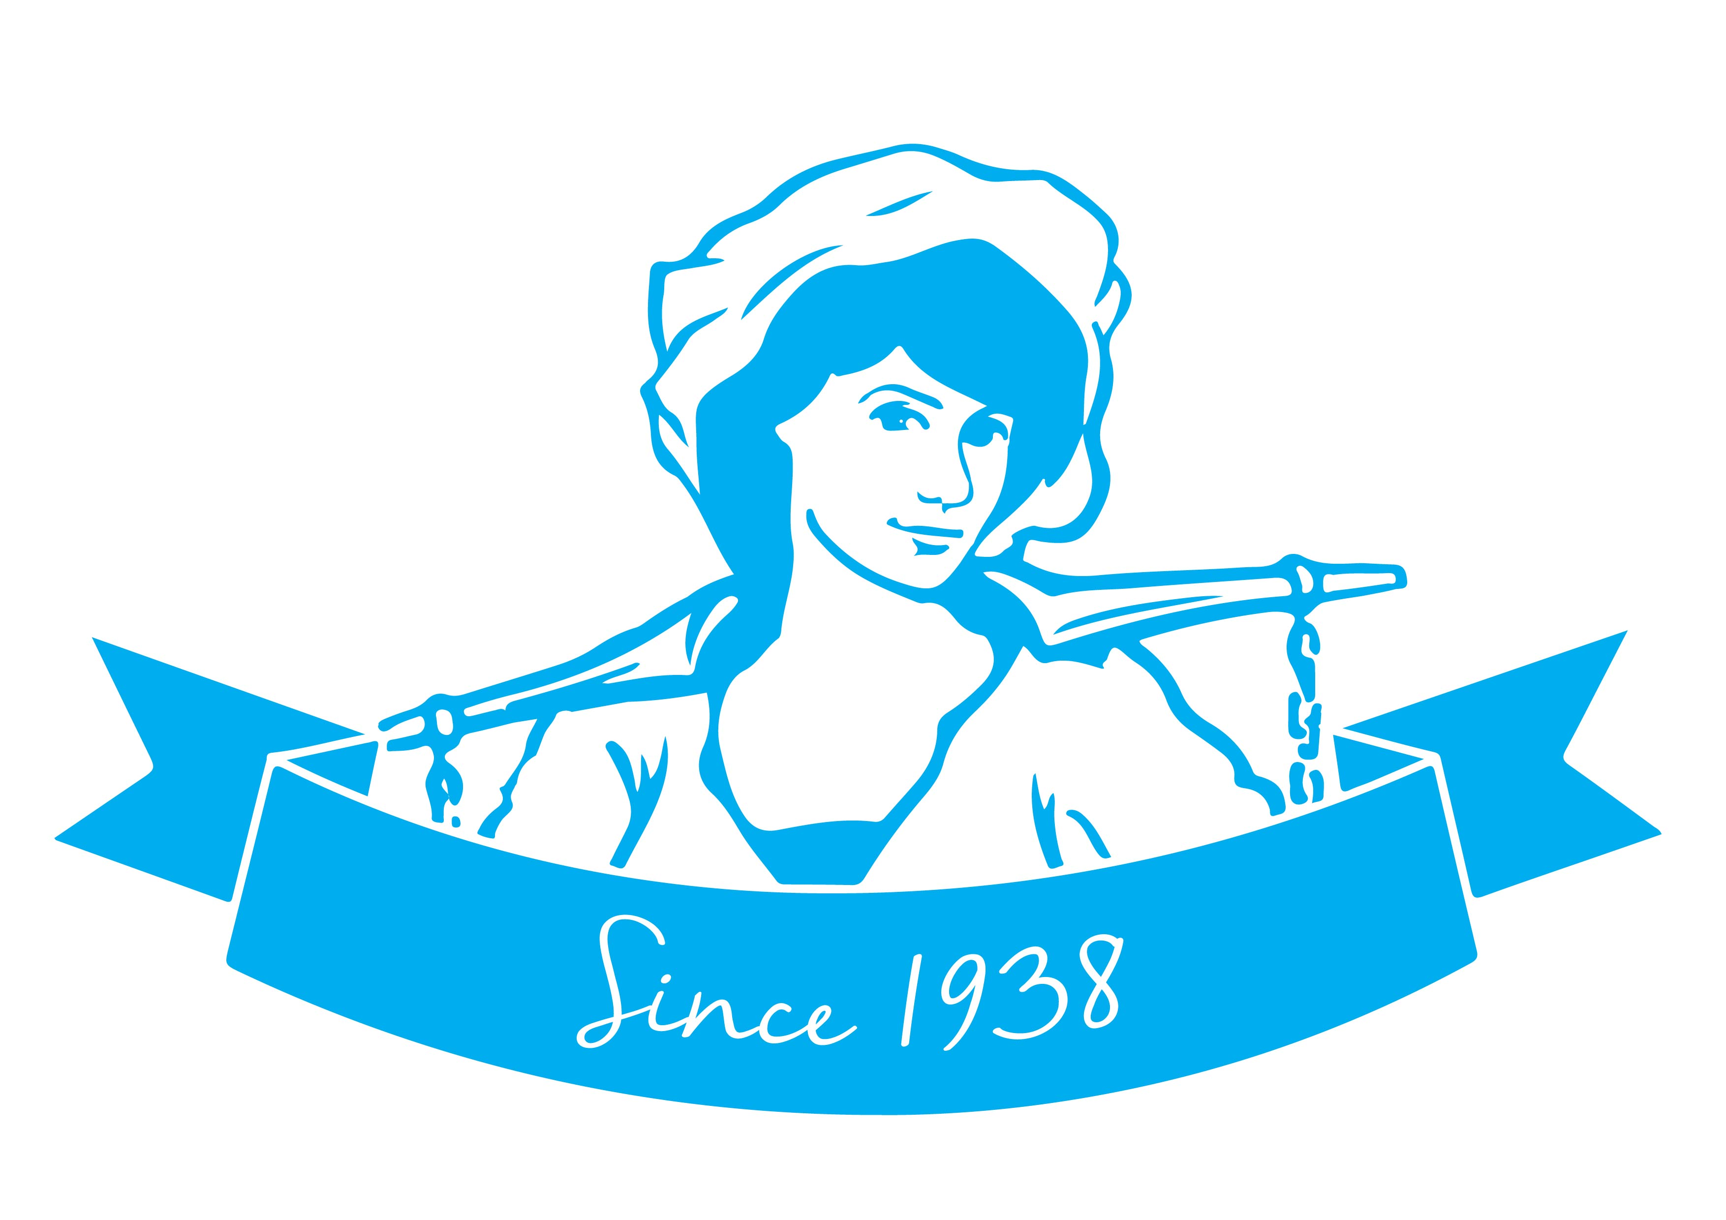
Class 2 / Cat C Drivers – Tewkesbury Depot (HR241)
Permanent, Full time hours as required over 7 days per week
Includes nights and weekends

Are you an experienced Cat C Driver?
Or have you recently gained your LGVC category looking to embark on a new career?

Established in 1938, Cotteswold Dairy is one of the UK’s leading independent, family-owned dairies. We support local farmers and communities by delivering the freshest, finest quality products and first class customer service.

We have an exciting opportunity for an enthusiastic LGV / HGV Driver with excellent customer service skills and a Cat C/Class 2 driving licence to join our Cotteswold family. We welcome Drivers who have recently gained their LGVC category, particularly those with a passion to learn and develop.

You will work on a rota basis over 7 days per week. This will therefore include weekend working. You will be working nights as rounds leave the Tewkesbury depot between 10pm and 3am daily.

This position will involve you driving a Cat C/Class 2 vehicle, delivering dairy and other products to wholesale customers. This is an active role which will require you to undertake manual handling and is quite physical as you will be loading and unloading at customer sites.

You will have:

- A Driver Certificate in Professional Competence (DCPC) – however, training may also be provided subject to a training agreement
- A clean UK/EU driving licence LGV (Class 2 / Cat C)
- A Digital Tachograph Card
- An eye for detail to ensure accuracy and precision
- Experience of delivering excellent customer service and building good customer relationships
- Good time keeping and flexibility to work shifts - 5 days over 7 days
- The ability to work night shifts and weekends

We are committed to training and giving you the skills and abilities to carry out your role, providing progression and opportunities, allowing you to build a long term relationship with the Company. In addition to this, we offer:

- Competitive salary, enhanced by a driving bonus | - Cycle to Work Scheme
- 30 days holiday inclusive of Bank Holidays | - Refer a Friend Scheme – potentially receive £250
- Group Personal Pension Scheme – 4% Employer contribution | - Employee shop – discounted products and potential free delivery
- Online employee benefits platform | - Free car parking

For an informal discussion about the role, please contact the Fleet Logistics Manager on 01684 298959.
To download your copy of the accompanying Job Description, and to apply please visit www.cotteswold-dairy.co.uk, or email hr@cotteswold-dairy.co.uk to find out more.

On receipt of your application, we will collect your name, contact details and other relevant information for recruitment purposes. The information you provide will help us determine your suitability for any vacancy we have. We understand how sensitive this information is which is why we are committed to safeguarding any data we do collect.

