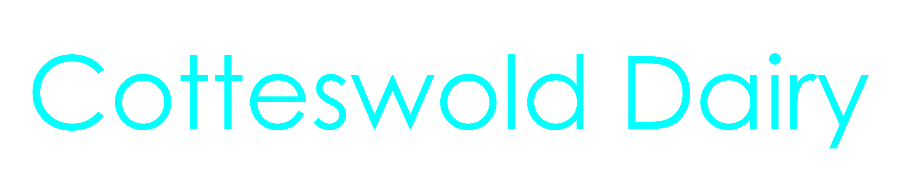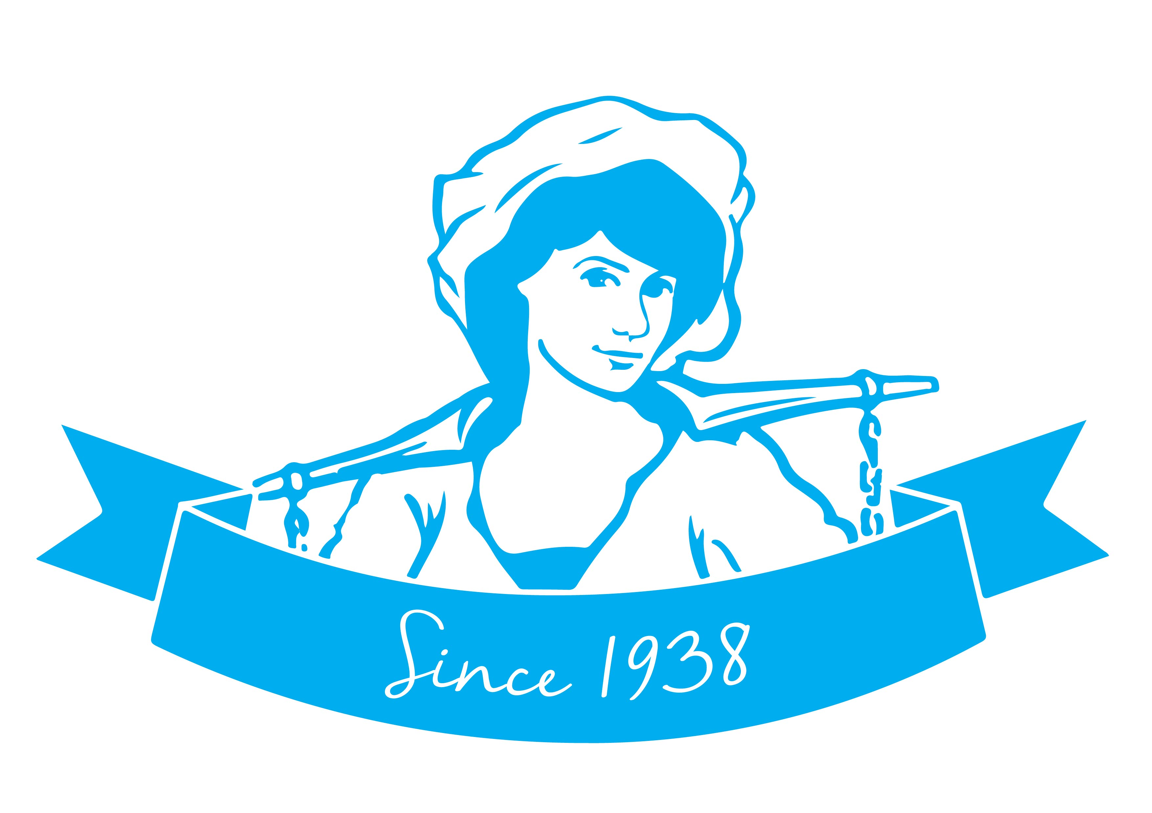
TT196 – Quality Technician
Full Time (working 40 hours p.w.), Permanent
Salary £25,000 - 27,000 per annum

Cotteswold Dairy is a successful family business who, with over 80 years in the dairy industry, have become one of the largest independent family run dairies in the UK. Cotteswold has a strong family ethos and our employees reflect our values by delivering service with Quality, Service and Cleanliness at the core.

We are proud to hold AA standard with the British Retail Consortium (BRC), and as the new Quality Technician you will play a key role in conducting audits and taking a hands on role in the Factory to ensure the quality of our products. This is an exciting role which offers the opportunity to continuously improve practices and make a difference to the business.

The successful candidate will:
- Have excellent attention to detail with clear focus on end results.
- Strong communication skills; being able to foster and maintain excellent working relationships.
- Have a positive attitude, possessing high levels of commitment, motivation and flexibility.
- The ability to work in an analytical and structured manner.
- Innovative and forward looking, seeking ways to constantly improve.

Ideally you will have HACCP (Hazard analysis and critical control points) knowledge and strong food safety knowledge, with knowledge of the dairy industry.

Day to day, you will:
- Assist the Technical Manager with implementing, monitoring and developing quality control programmes;
- Help to monitor the production department’s conformance with quality systems;
- Understand and assist with audit quality management systems;
- Review company operations to ensure legal compliance.

To view the full role information please see the Job Description, which follows this page.

We are committed to giving you the skills and abilities to carry out your role, providing opportunities to allow you to build a long term relationship with the Company. In addition, we also offer benefits including:
- Competitive salary | - Cycle to Work Scheme
- 30 days holiday inclusive of Bank Holidays | - Refer a Friend Scheme – potentially receive £250
- Group Personal Pension Scheme – 4% Employer contribution | - Employee shop – discounted products and potential free delivery
- Online employee benefits platform | - Free car parking

If you believe you fulfil the above criteria, please send an updated CV or complete an application form (available at www.cotteswold-dairy.co.uk), and write a covering letter, detailing why you believe you are the best candidate for the role and send it to hr@cotteswold-dairy.co.uk

Job Title | Quality Technician
Department: | Technical
Base Location: | Tewkesbury Depot
Hours: | 40 hours per week
Relationships: | All Departments and External bodies
Responsible to: | Technical Manager
Responsible for: | None

Established in 1938, Cotteswold Dairy is one of the UK’s leading independent, family-owned dairies. We support local farmers and communities by delivering the freshest, finest quality products and first class customer service.
Team Cotteswold:
At Cotteswold Dairy we recognise that we will achieve far greater success working as a team, with empathetic people management and valuing each other, our staff and our customers.
The aim of ‘Team Cotteswold’ is to give a disciplined and determined effort to value everyone and everything and as a consequence make the Company the first preference for employees and customers alike over the long term.
The Team Cotteswold Vision:
A well-managed business, with controlled profitable growth, that has an excellent reputation and is recognised as a place of opportunity where people are motivated to work. The Factory Manager role is key in supporting this vision.
JOB DESCRIPTION
Overview:
The Quality Technician is responsible for Quality duties within the Production areas of the Company. This will be a proactive role and will include the Factory floor.
Main Duties & Responsibilities:
The main responsibilities and functions of this role include:
- Assist the Technical Manager with Implementing, monitoring and developing quality control programmes.
- Help to monitor the production department’s conformance with quality systems.
- Understand and assist with audit quality management systems.
- Review company operations to ensure legal compliance.
- Assist with the company’s safety programmes in order to protect employees and the Company against harm, and maintain a safe working environment.
- Work towards meeting the requirements for site accreditation schemes and legal compliance.
- Manage and complete internal audits (within team)
- Assist with running and review of HACCP and food fraud systems
- Encouraging GMP across all product lines and ensuring compliance with existing legislation.
- Troubleshooting and resolving non conformity via root cause analysis.
- Play a key role in supporting the production department and laboratory.
- Manage, investigate and trend customer complaints and additional KPI’s.

Skills:
Essential:
- Excellent attention to detail with clear focus on end results.
- Strong communication skills; being able to foster and maintain excellent working relationships.
- Positive attitude possessing high levels of commitment, motivation and flexibility.
- The ability to work in an analytical and structured manner.
- Innovative and forward looking, seeking ways to constantly improve.
- GCSE English and Maths (or equivalent).
- Formal food safety qualification.

Desirable:
- Knowledge of dairy industry.
- Food Safety knowledge.
- HACCP knowledge.

