Adjectives and Nouns

Below you will find some cards with adjectives and nouns that represent or characterise places or objects in the Castle. Cut the cards, shuffle them and then pick them one by one. Find the place/object related to the word that you have picked and try to make a creative sentence with it about the Castle.
You can also try to find where they fit best on the drawing below.
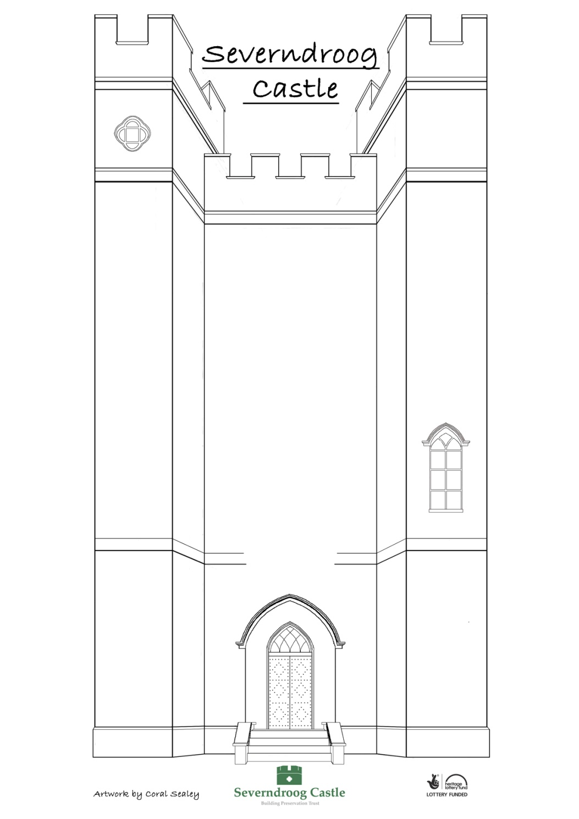

HEIGHT | SPOOKY | SOLID
CHILLY | TALL | OLD
SPIRAL | PEACEFUL | HIDDEN
WARM | BIG | STEEP
ORNATE | GLOOMY | PLAIN

TURRET | FLAG | ROOF
FLAGPOLE | TOWER | STAIR
WINDOW | WALL | SPIRAL
PANE | ARCH | PLAQUE
DOOR | BRICK | GLASS

