Severndroog Woodland Trail
Follow the numbered map

Can you find these features and places by exploring the woods on your way to the Secret Garden?
1 | 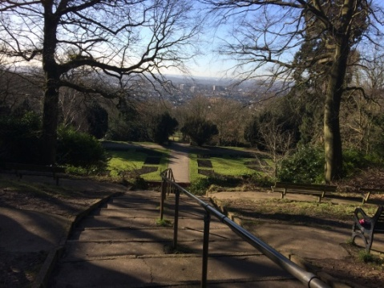 | 2 | 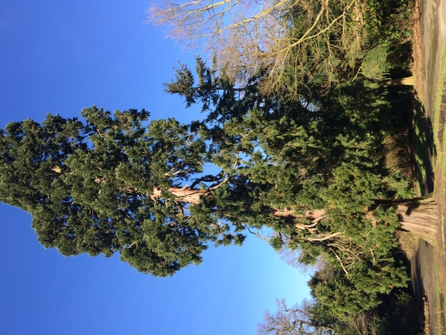 | 3 | 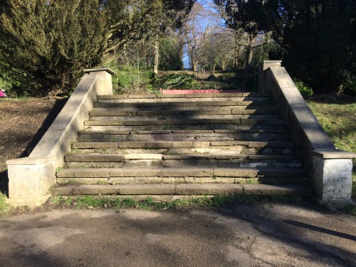
4 | 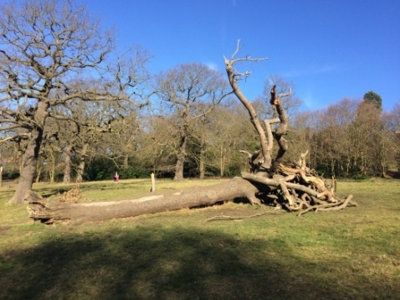 | 5 | 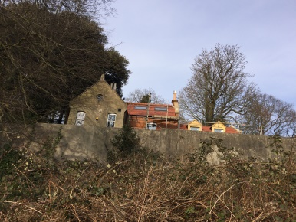 | 6 | 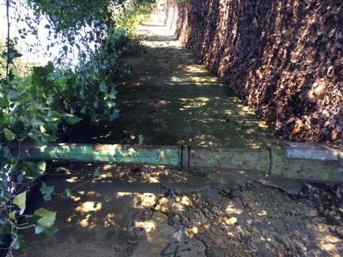
7 | 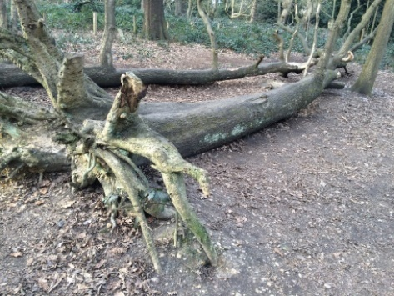 | 8 | 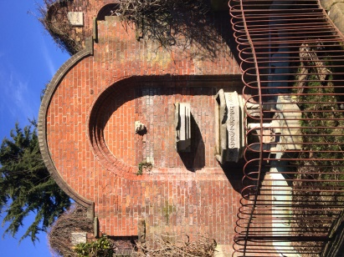 | 9 | 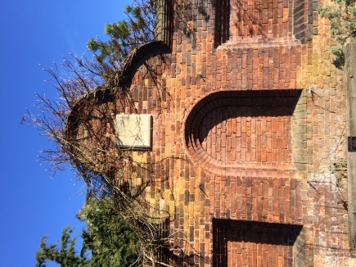
10 | 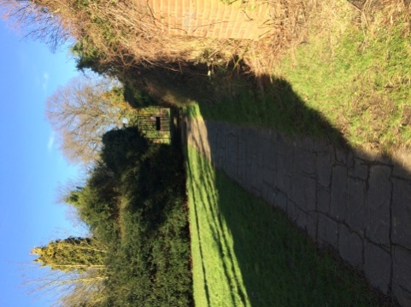 | 11 | 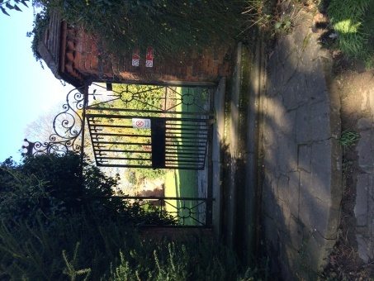 | 12 | 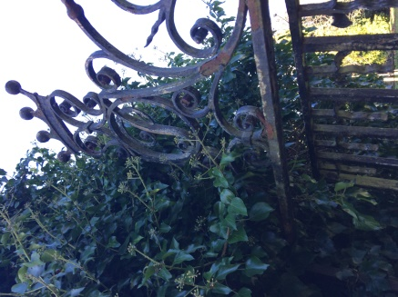

Included in Section 5: Green Chain Walk
http://greenchain.com/greenchainsite/info/5/walking/2/green_chain_walk_-_sections/5
- From the castle go down the steep steps to a formal rose garden
- Here you will find a huge monkey puzzle tree
- Go down some more formal steps and follow path to the left
- You can see the meadow with the fallen trees hit by lightning – you can run down and climb on the trees
- OR carry on walking along the wall (above which you can see the Keeper’s House being renovated)
- You can either follow the Stoney Alley path with green lamp post going up on your sharp left and then right at the top towards the Walled Garden
- OR stay on the Green Chain path going into Jack Wood. You will go past another fallen tree
- Then you will follow path right into the walled garden area
- Before you turn left to find the path to the Secret Garden, go and explore the red brick walled garden with the water fountain
- There is even a secret archway back towards the Secret Garden!
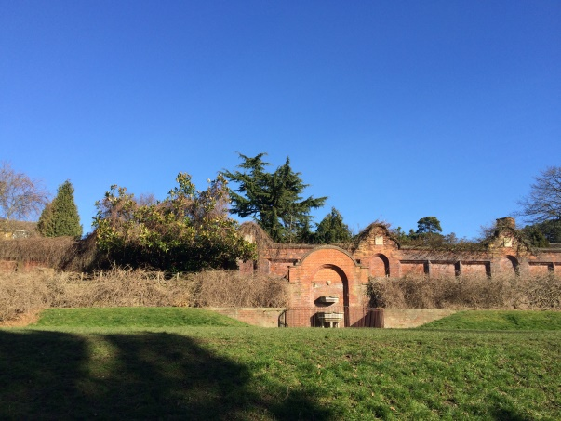
You will have gone too far if you pass the gardens
and reach Oxleas Meadows and the Café (with toilets).
Complete the rest of your trail worksheet and then return to the Castle for your certificate.

The Walled Garden
The Secret Garden
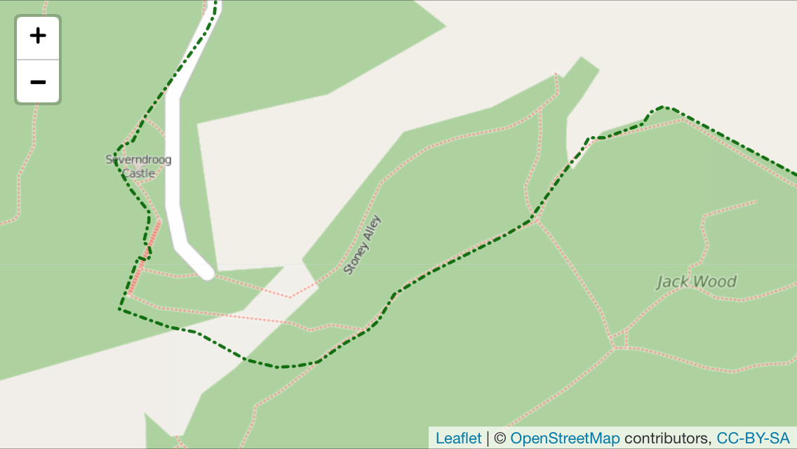
7
10
9
8
6
5
3
4
2
1

The formal rose garden with the monkey puzzle tree belongs to Castlewood. It is symmetrical which means it is identical on both sides. Can you draw the other half?

1

2
Did you know…? The woods are at least 8,000 years old. In the meadow or woods, you’ll find a few good friends. Can you spot them? (If you don’t see them all don’t worry, some of them are a bit shy)
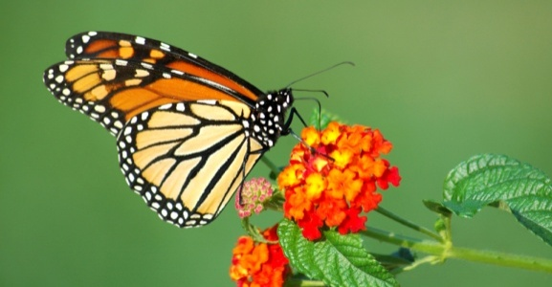
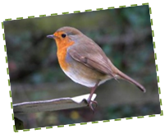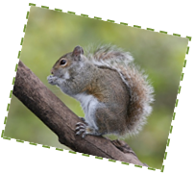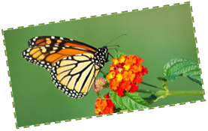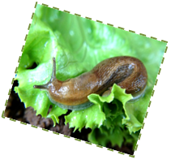
Did you know…? The woods you have right in front of you are at least 8,000 years old. Carry on through the path, now you are going to enter the woods, there you’ll find a few good friends. C
Can you spot them? (If you don’t see them all don’t worry, some of them are a bit shy)
Did you know…? The woods you have right in front of you are at least 8,000 years old. Carry on through the path, now you are going to enter the woods, there you’ll find a few good friends. C
Can you spot them? (If you don’t see them all don’t worry, some of them are a bit shy)
3
The Walled Garden is Victorian and it was part of a manor house which is no longer here. There are some hidden inscriptions in the garden - can you find them and draw them here?
A U D H N Z Y O W R
E R U T N E V D A H
K V L Z Q N D B B F
W O O D S K K R G I
T S E R O F I A A E
Y E E L T S A C Z G
F O U N T A I N O G
M A E R T S D P Q H
Q G K O X F A V Q S
B I P I A C I W V S

Fountain, Adventure, Castle, Woods, Garden, Stream, Forest
A U D H N Z Y O W R
E R U T N E V D A H
K V L Z Q N D B B F
W O O D S K K R G I
T S E R O F I A A E
Y E E L T S A C Z G
F O U N T A I N O G
M A E R T S D P Q H
Q G K O X F A V Q S
B I P I A C I W V S

Fountain, Adventure, Castle, Woods, Garden, Stream, Forest

4
This is the Secret Garden, take your time to explore around, pick something that you like, what can you tell us about it?

____________________________________

____________________________________

This is the Secret Garden, take your time to explore around, pick something that you like, what can you tell us about it?

____________________________________

____________________________________

Explore the Secret Garden - play tag or hide n’ seek! Pick something that you like about the trail or gardens, what can you tell us about it?

This is the Secret Garden, take your time to explore around, pick something that you like, what can you tell us about it?

____________________________________

____________________________________

This is the Secret Garden, take your time to explore around, pick something that you like, what can you tell us about it?

____________________________________

____________________________________

This is the Secret Garden, take your time to explore around, pick something that you like, what can you tell us about it?

____________________________________

____________________________________

A U D H N Z Y O W R
E R U T N E V D A H
K V L Z Q N D B B F
W O O D S K K R G I
T S E R O F I A A E
Y E E L T S A C Z G
F O U N T A I N O G
M A E R T S D P Q H
Q G K O X F A V Q S
B I P I A C I W V S

Fountain, Adventure, Castle, Woods, Garden, Stream, Forest
A U D H N Z Y O W R
E R U T N E V D A H
K V L Z Q N D B B F
W O O D S K K R G I
T S E R O F I A A E
Y E E L T S A C Z G
F O U N T A I N O G
M A E R T S D P Q H
Q G K O X F A V Q S
B I P I A C I W V S

Fountain, Adventure, Castle, Woods, Garden, Stream, Forest
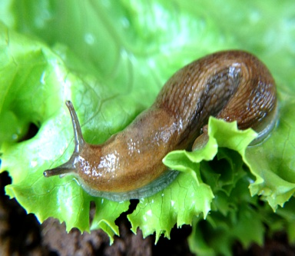
Complete your trail worksheet and then return to the Castle for your certificate. Well done!
Did you know…? The woods you have right in front of you are at least 8,000 years old. Carry on through the path, now you are going to enter the woods, there you’ll find a few good friends. C
Can you spot them? (If you don’t see them all don’t worry, some of them are a bit shy)
Did you know…? The woods you have right in front of you are at least 8,000 years old. Carry on through the path, now you are going to enter the woods, there you’ll find a few good friends. C
Can you spot them? (If you don’t see them all don’t worry, some of them are a bit shy)

