Building and Symmetry

Severndroog Castle has three faces or sides: the south-east, south-west and north faces. The main entrance is on the south west face.
Look carefully at each side and each floor and add to the drawings below the missing features such as windows of different styles, doors, merlons or battlements, and water pipes.

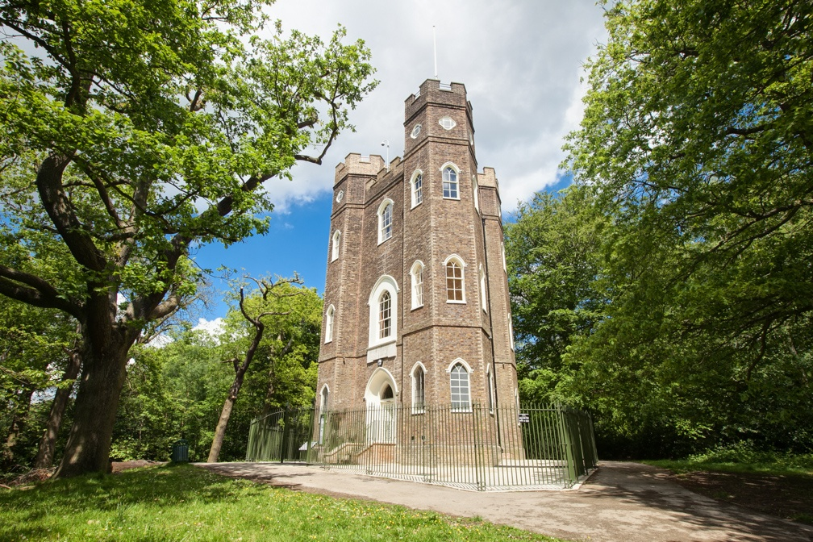

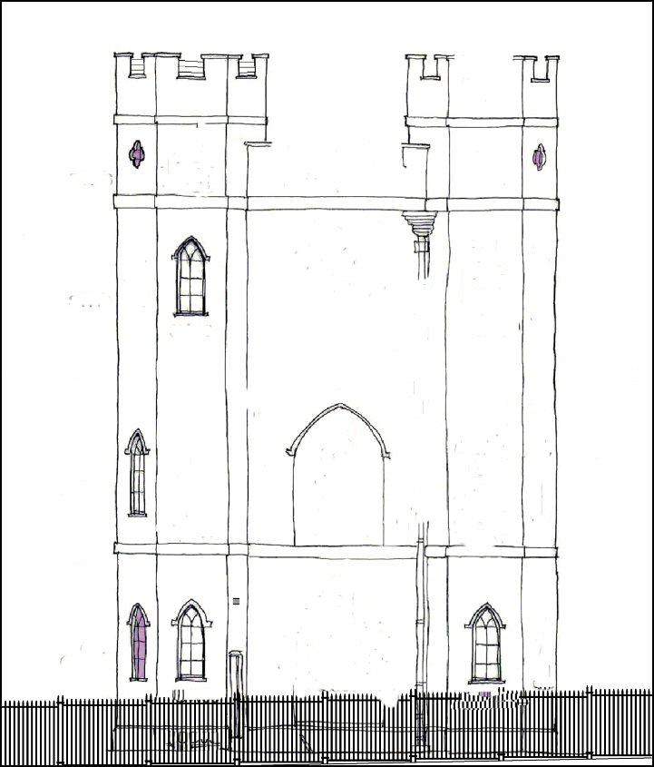

(South East face)

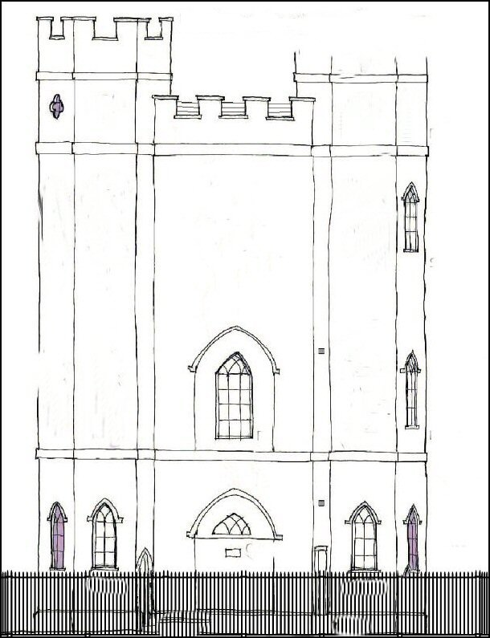
(North face)

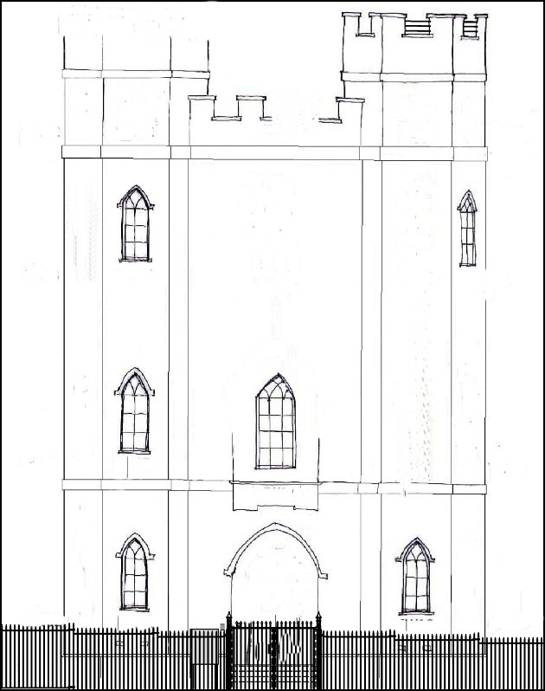
(South West face)

