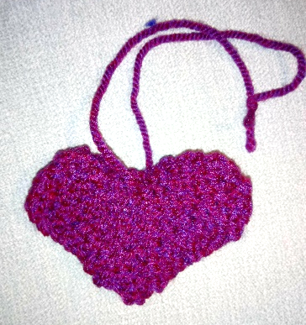

Using 4mm needles and any colour DK or chunky wool
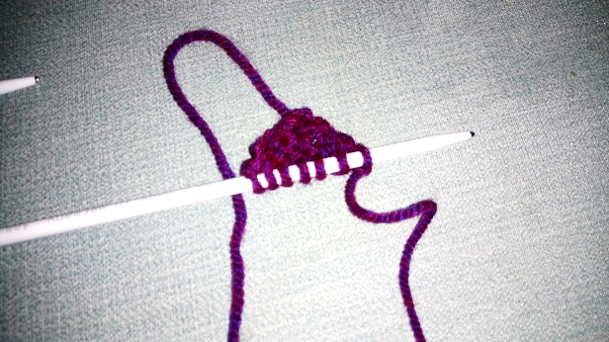
Cast on 3
1. Knit
2. KFB, K1, KFB (5 stitches)
3. Knit
4. KFB, K3, KFB (7 stitches)
5. Knit

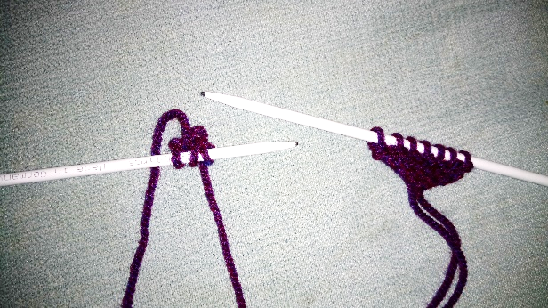
Cut yarn & move hump down your needle
Starting on the other needle repeat rows 1-5 to make second hump

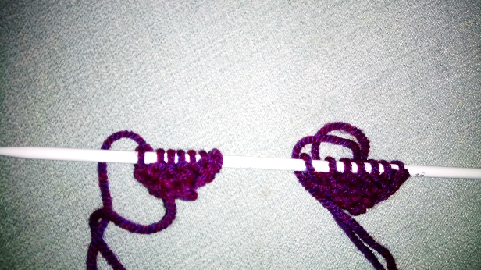

With both humps on same needle continue knitting

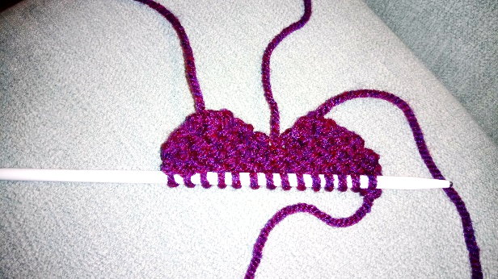

6-8. Knit (14 stitches)

9. K2tog, k10, k2tog (12 stitches)
10. Knit
11. K2tog, k8, k2tog (10 stitches)
12. Knit
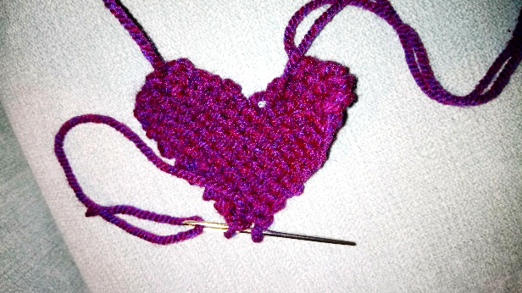
13. K2tog, k6, k2tog (8 stitches)
14. Knit
15. K2tog, k4, k2tog (6 stitches)
16. Knit
17. K2tog, k2tog (4 stitches)
18. Knit
19. K2tog (2 stitches)
20. Using a needle thread through remaining 2 stitches and pull tight

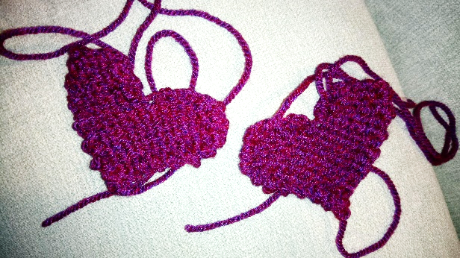
Make another heart the same and stitch the two together.

Attach a 30 cm loop of wool as a hanger at the top of the heart and it’s all done!

If possible, and you are making more than 10 hearts, please can they be tied together in 10s to make it easier to keep track of when we reach the magic 10000th heart

THANK YOU SO MUCH AND HAPPY KNITTING

http://www.workofheartgarden.org/

