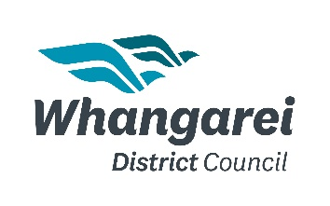
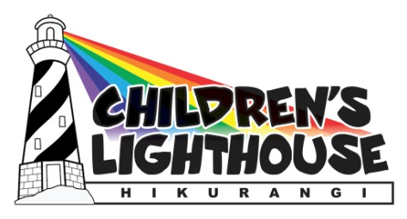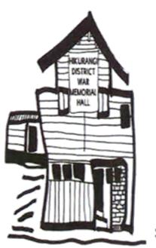

Hikurangi Xmas Parade
Saturday 11th December 2021
Registration form for anyone in Whangarei District

Name of Organisation/Group: _________________________________________________
Contact person: _____________________________________________________________
Mobile number: ___________________________________________
Email address: ____________________________________________
Thanks to our local Ray White “We can help with that” funding. Here are the divisions are up for grabs!!!!
PRIZES:
Floats = 1st prize $300, 2nd prize $150, 3rd prize $50
Walking Groups (with youth participation) = 1st prize $300, 2nd prize $150, 3rd prize $50
Community Spirit Awards = 1st prize $300, 2nd prize $150, 3rd prize $50 – This division is subject to confirmed sponsorship.
Parade registration (12 noon )– Yes I would like to be in parade
Hikurangi Lions in conjunction with Hikurangi Friendship House and Hikurangi Business Association is going all out this year. We are going to have the biggest parade & festival in our village. Last year was a huge success, this year we have made sure it doesn’t clash with Whangarei Agricultural Show so all the horse clubs, farmers and business can attend. Everyone is welcome to participate in this iconic event - floats, walkers, club, animals, motor-bike clubs (no patches), farmers etc.

Please highlight what you intend to do, can be a combination e.g.
We will be having a: Float/truck Walking group Multiple vehicles
Car & walking group Semi trailer Approx length you require: ……………..........

Will you be having animals or anything special that we need to know about that maybe sensitive to noise etc? Yes / No (please comment)……………………………………………………………………………………………………………
All registrations can be emailed to Arlene@tiaho.org.nz

