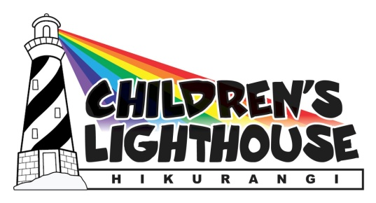

Hikurangi Christmas Parade & Festival
Saturday 5th December 2020
Street Stall & Stage Entertainment Registration Form

Name of Organisation/Group/School:
Contact person:
Mobile number:
Email address:

Live Entertainment registration (9am start, 12pm finish)
Yes I would like to be in the entertainment
There will be three divisions of entertainment, trophies & prizes for each division:
- Kapa Haka - 1st & 2nd Prize = activity vouchers for summer
- Groups - 1st & 2nd Prize = activity vouchers for summer
- Individuals - 1st & 2nd Prize = activity vouchers for summer
Contact Sharlene for further information: 021 616 755
Email: Admin@hikurangi.co.nz
I would like to enter into the following categories (please circle or highlight):
Kapa haka Groups Individuals
======================================================================
Street Stall registration (9am start, 1pm finish)
Yes I would like to have a street stall
What will you be selling? ……………………………………………………………………………………………………………………….
If food do you have a Health licence from WDC?......................................................................................
All registrations can be emailed to Sharlene - Admin@hikurangi.co.nz
Or Phone Friendship House 433 8452

