Vladimir Gorbach
Classical Guitarist

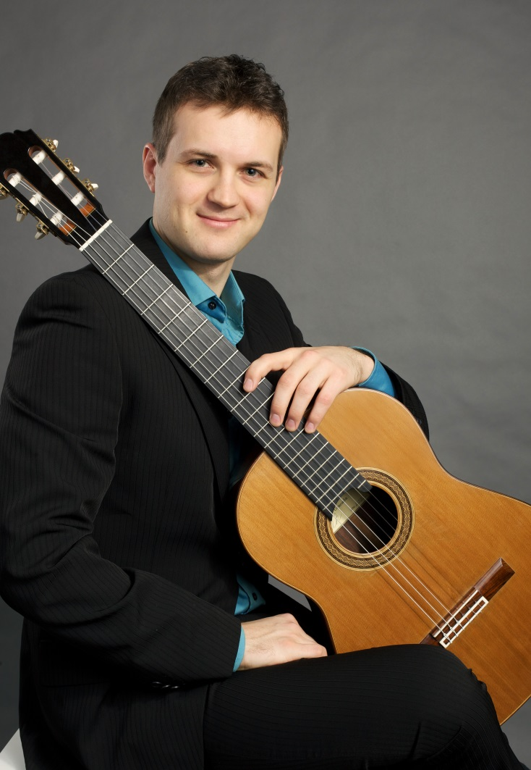
Internationally acclaimed guitarist Vladimir Gorbach has captivated audiences across Europe, Australia, the United States and his native country of Russia.
His international success began when he was accepted into the Yehudi Menuhin Foundation "Live Music Now" outreach program. He then went on to win many international guitar competitions and prizes in Spain, Italy, Germany, Portugal, Greece and the 2011 Guitar Foundation of America earning him a full season concert tour throughout North America, including at Debut Carnegie Hall, NY; Canada, Mexico, South America, and China, in addition to a publication with Mel Bay and a recording for Naxos label distributed worldwide.
Recent highlights include tour of Japan, 2015 La Guitarra California Festival, appointment as faculty of guitar at Sydney University and opening the season for the Boston Classical Guitar Society season and recital for the Seattle Classical Guitar Society while taking on a part-time faculty role at the California State University, Fullerton, in addition to being selected as the first International Artist Fellow in Music at the University of Southern California, Thornton School of Music to pursue his Doctoral of Musical Arts (DMA) studies. (USC's most elite graduate fellowship in the Arts granted annually to only one fellow in each of five arts schools at USC).
He has performed in recital and as soloist with chamber ensembles of Orchestra de Las Beiras, the Orchestra de Aveiro, the Russian Academic Chamber Orchestra Musica Viva, the Symphony Orchestra of New Russia, and Junge Philharmonie Köln , as well as appearances at the Moscow Philharmonic Concert Series, Koblenz International Guitar Festival (Germany), Guitar Art Festival Belgrade (Serbia), Vienna Guitar Forum (Austria), Nantes Summer Guitar Academy (France), Vondelpark Festival (The Netherlands), and Sydney Crows Nest Concert Cycle (Australia), in addition to giving master-classes at numerous festivals.
He began his guitar lessons at an early age in the class of Professor Yuri Kuzin at the State Music School in Novosibirsk and later with Arkady Burkhanov at the Glinka Conservatory. He continued his studies at the Music Academy in Cologne, Germany with Roberto Aussel.
Mr. Gorbach plays a 2005 Daniele Chiesa instrument fitted with Augustine Strings.
Official bio for 2015-16 Season

