Eli Shukron and Yoel Bin-Nun
A Matzevah Temple from the Period of the Patriarchs in the City of Salem, Later the City of David

The archaeologist Eli Shukron excavated in the City of David together with Prof. Roni Reich on behalf of the Israel Antiquities Authority for a period of 17 years. Among their discoveries was the large pool connected with the Gihon Spring, located just to its south, together with the spring’s enclosure. In 2010, an unusual structure was uncovered just above the pool and the enclosure, containing the following features:
An entrance staircase from the east that leads to a flat surface hewn in the rock, with several parallel rooms – the most important of which is the room with the matzevah, in the central part of the building. The entrance staircase and the rooms hewn into the rock are clearly components belonging to a single structure.
The matzevah –
The unique matzevah is made of a thin slab of rock whose width is a mere five centimeters. Its height is 55 cm. and its length is 85 cm. This plain slab of rock, which contains no images, was found placed on an exposed, hewn stone, and is held in place with strong supporting rocks that were placed beneath it and around all of its sides.
Photo credits: Vladimir Neichen
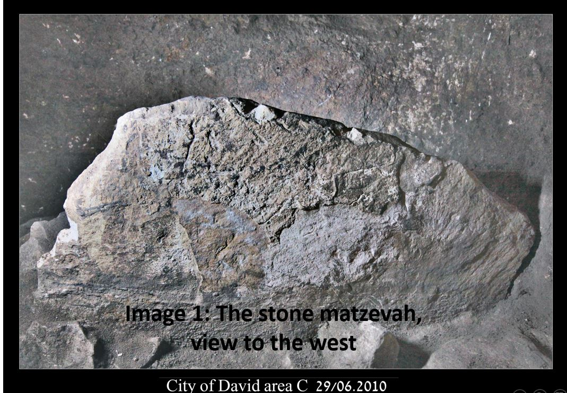
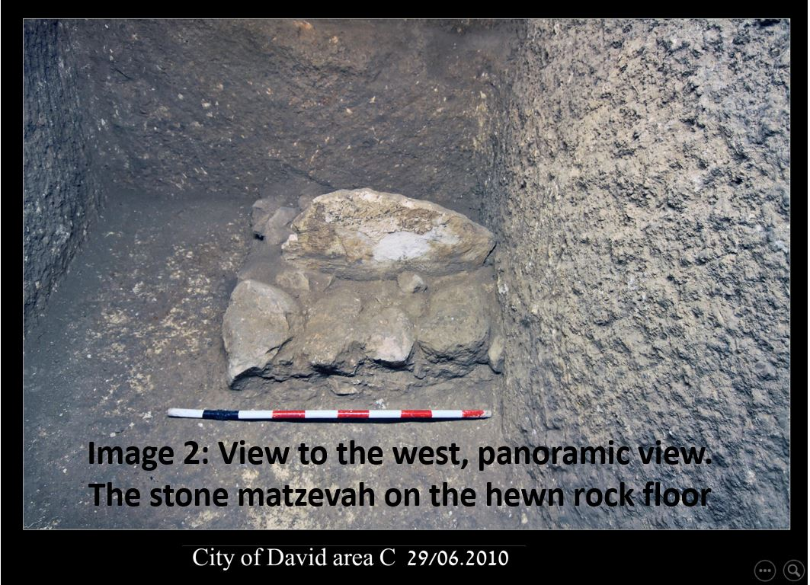
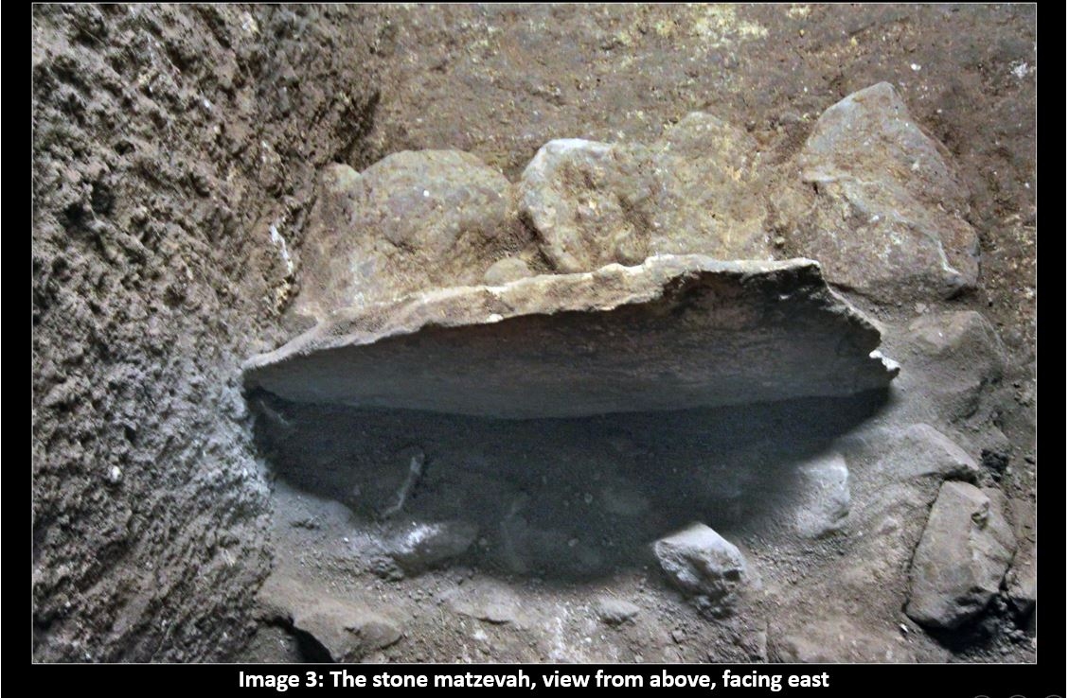
The altar room –
A slightly raised hewn square was uncovered in the corner of a room north of the matzevah room, with a small drainage ditch adjacent to it. The dimensions of the square are 145 X 100 cm, and they seem to indicate an altar that was placed there; the small drainage ditch greatly strengthens this supposition.
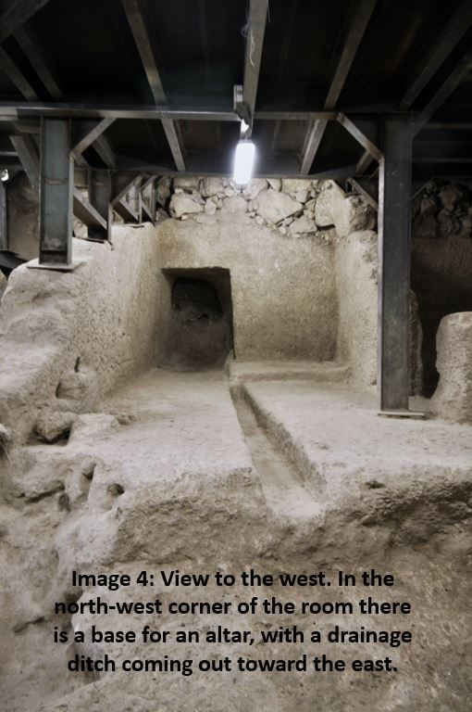The olive press –
In the room to the north of the slab of rock is a small hewn olive press, apparently intended for the production of special sacred oil, to be used in the central service of the matzevah temple. The dimensions of the oil press are 220 X 155 cm; it is clear that only small amounts of oil were produced here, as the amount produced would not be sufficient for domestic consumption, nor for public worship.
The room behind the olive press –
Behind the olive press is a small room, probably used as a warehouse, where many fragments of broken jars were found on the floor.
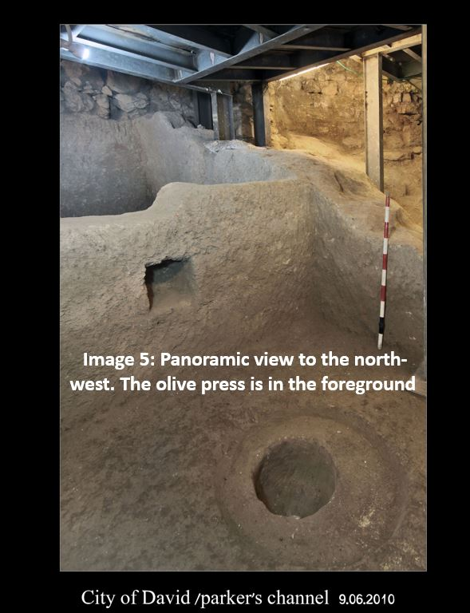
Ceramic finds and dating –
In the eastern part of the complex, potsherds that can be definitively dated to the 18th century BCE were found, which is the period (Middle Bronze Age IIB) of the large fortification towers above the Gihon spring, and of the large pool that was uncovered south of the spring.
We can therefore conclude that the temple of the matzevah was an integral part of the fortification around the spring and of the pool, and that it marks the religious identity of the city to that ancient period, that is, the period corresponding to the days of Melchizedek and Abraham.
The floor hewn into the rock of the rooms of this temple has no layers, and was very easy to clean during all periods of its activity. For this reason, only a few potsherds from the final period of the temple's activity remain, that is, from the 8th century BCE.
The connection between the findings and the Book of Genesis
The unique connection between the thin stone matzevah, positioned vertically, and the oil that was prepared in the oil press found in the temple, can be understood by examining the biblical story found in the Book of Genesis (28:16-18) –
Jacob awoke from his sleep and said, “Surely the LORD is present in this place“… How awesome is this place! This is none other than the abode of God, and that is the gateway to heaven.” Early in the morning, Jacob took the stone that he had put under his head and set it up as a pillar and poured oil on the top of it.
According to the biblical account, Abram gave a tithe to Melchizedek, King of Salem, who was a priest of God Most High… And [Abram] gave him a tenth of everything (Gen 14:18-20), that is, he gave him a tenth of what was taken in battle. The tithe connects between this story and Jacob’s temple matzevah in Beth-El. In that story, Jacob stood before the matzevah upon which he poured oil and promised to separate a tithe in the future –
“…the LORD shall be my God. And this stone, which I have set up as a pillar, shall be God’s abode; and of all that You give me, I will set aside a tithe for You.” (Gen 28:21-22)
The entrance from the east is reminiscent of other Judean temples (e.g. Tel Arad), and this is the direction of entrance that we find in other places in the Bible, as evidenced by the Tabernacle (Exod 27:13-16) and in Ezekiel’s prophecy (8:16), where he rails against the sinners (at the end of the First Temple period) who stood at the entrance to the Temple of the LORD… their backs to the Temple of the LORD and their faces to the east; they were bowing low to the sun in the east. The entrance from the east is also found in Ezekiel’s plans for the future Temple, and God’s presence will return to the Temple from the gate that faced eastward (Ezek 4:6, 43:1-2. See also Zech 14:4). From Ezekiel's harsh words against the sinners we understand that the belief in God expressed in the Temple stood in stark contrast to the worshipers of the sun, who bowed to the east – most likely at sunrise. The monotheistic faith of the Bible arranged an entrance from the east so that the sun would rise to shine upon the entrance of the Temple as if it were bowing down to the Creator of heaven and earth, sun and moon, and all they contain.
Other important characteristics
In addition to noting the entrance from the east, in the structure itself we find: A sacred matzevah with an oil press – apparently producing oil for ritual libation on the matzevah – together with the base for an altar (with a drainage ditch). These findings stand in stark contrast to Canaanite and pagan temples with which we are familiar throughout the area.
A significant insight that can serve to explain this complex can be found in the verses of Genesis, relating to the city of Salem.
And King Melchizedek of Salem brought out bread and wine; he was a priest of God Most High. He blessed him, saying, “Blessed be Abram of God Most High, Creator of heaven and earth. And blessed be God Most High, Who has delivered your foes into your hand.” And [Abram] gave him a tenth of everything (Gen 14:18-20).
In the following verses, Abram echoes the prayer of Melchizedek, while adding the personal name of God – I swear to the LORD, God Most High, Creator of heaven and earth…(Gen 14:22).
Both traditional commentaries and contemporary scholars agree that the city of Salem should be identified as Jerusalem, which, after a time, will become known as “the City of David” (2 Sam 5:9), and the well-known verse in Psalms (76:3) Salem became His abode; Zion, His den, connects Salem with Zion.
The formulation of Melchizedek's religious perspective as it appears in the book of Genesis is not a Canaanite formulation, despite the use of such familiar names in the Canaanite-Phoenician region. As Prof. M.D. Cassuto has noted, we never find the name 'El-Elyon' (translated here as God Most High) articulated in this manner among the Phoenicians. They viewed these two names as relating to two different deities.
We can conclude that the expression God Most High, Creator of heaven and earth articulates an early monotheistic belief that proclaims that El (God) is most high, He is the One who created heaven and earth. Furthermore, He is the God who rules over the kings on earth and delivers them into the hands of those who are loyal to Him, like Abram, the Hebrew.
The temple of the matzevah, built with an entrance from the east, and located above the spring in the city of Salem – later the city of David – is most appropriate for this king-priest, who expresses a monotheistic worldview.
We must not miss the subtle difference between the faith of the Patriarchs and that of Melchizedek – a subtle but important difference – expressed in the addition of the name of God when Abram speaks.
In the chapters relating to the Patriarchs in the book of Genesis it is evident that God revealed Himself to them in various places throughout their wanderings, and that He also commanded them to travel by His power and with His help. Time and again we find commands to Abram like Go forth (12:1), Up, walk about the land (13:17), Walk in My ways (17:1). Regarding Jacob, in the dream in Beth-El that ended with the erection of the matzevah, the command he received was: Remember, I am with you: I will protect you wherever you go and will bring you back to this land... (28:15).
It appears that Melchizedek served as a permanent priest in a fixed temple, dedicated to God Most High, Creator of heaven and earth. Abram – who becomes Abraham – walks before the LORD, God Most High, Creator of heaven and earth in all of his treks and travels, including in his battle to save Lot. This is true of Jacob’s travels, as well, as evidenced by the temporary temple in Beth-El which he establishes when he leaves for Haran (Gen 28:10-22) and returns to on his journey home (35:9-15).
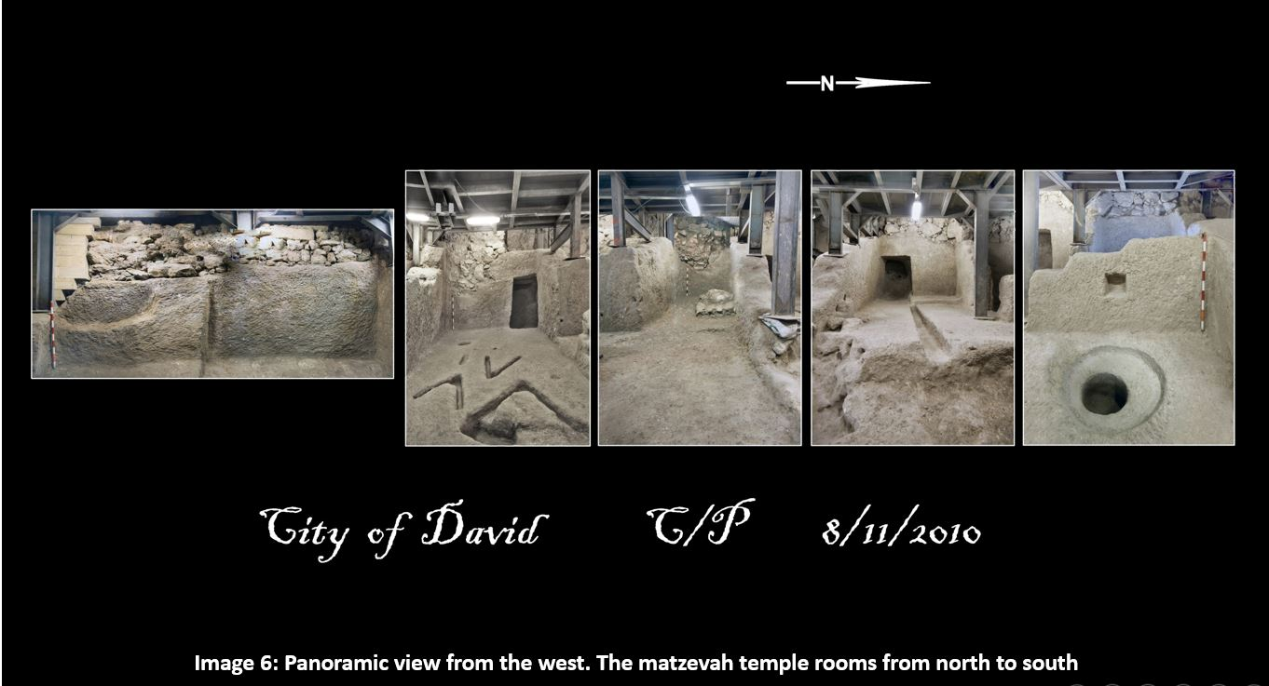
This meeting between Melchizedek and Abram symbolizes the encounter between wandering and permanence. The fact that it takes place precisely in the city of Salem – that is, in Jerusalem – has special meaning, which later found expression in King David's efforts. David made Jerusalem the "end of wanderings" of the Ark of the Covenant (2 Sam Chap 6), in preparation for building the House of God (1 Kngs, Chap 6-8), and, in doing so, David returned to the permanence of the temple of God in Jerusalem, as was the case in the time of Melchizedek. It is for this reason that the Psalm (Ps 110) that depicts David as the conqueror who defeats his enemies, and places him to the 'right' of God, can also refer to him as a King-Priest - The LORD has sworn and will not relent, “You are a priest forever, a rightful king (Melchizedek) by My decree” (110:4).
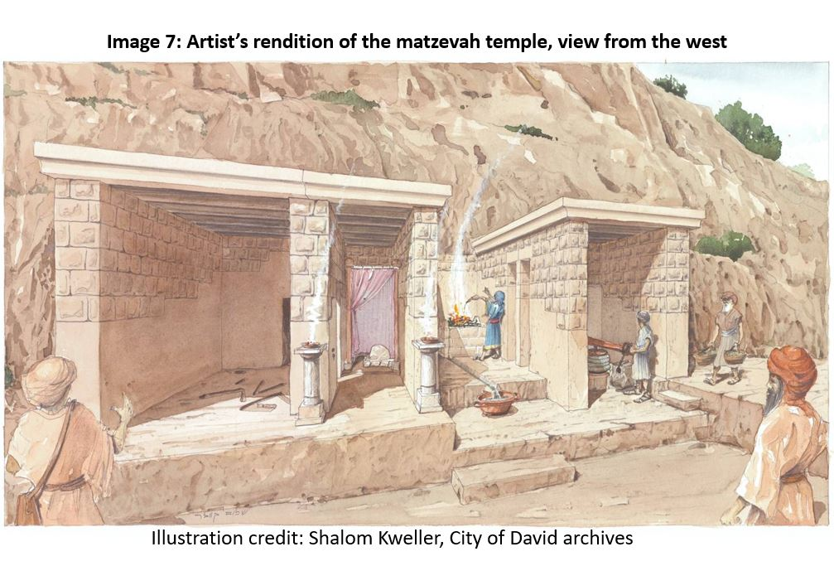
The Temple genizah
A small number of potsherds from the 8th century BCE were found on the hewn bedrock surface, which served as the floor of the inner rooms. Inside a cave adjacent to the bedrock wall, west of the altar and matzevah room, a complete set of vessels was found. These appear to have been stored there from the time of the abolishment of the matzevah temple in the 8th century BCE, that is, in the days of King Hezekiah. This is a direct testimony – from the city of Jerusalem itself – of Hezekiah's revolution to abolish bamot – “high places.” We can see exactly how a special wall was built on the eastern side, the matzevah was covered with dirt in a very careful manner, so as not to damage it, and the whole temple was covered with stones, and interred.
The fact that the temple and its vessels were interred in such a careful manner indicates that even during the period of Hezekiah’s revolution abolishing bamot, this place was not viewed as an idolatrous temple, particularly because it was where offerings were made to the LORD, God Most High, Creator of heaven and earth. Abram’s addition of the name of God served as proof to those who worshipped the God of Israel in later generations that this was a holy place. The careful interment of the temple indicates that this was accepted as fact in the days of King David as well as in the days of King Hezekiah.
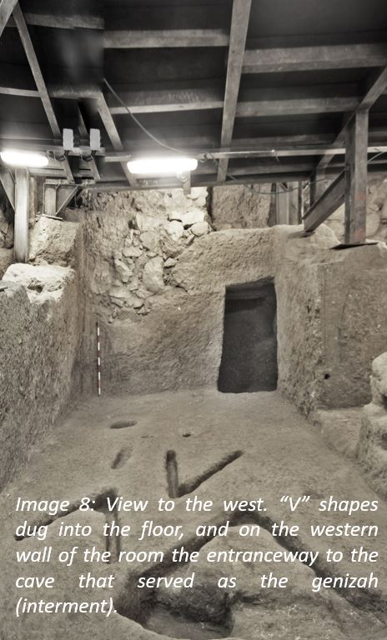
The matzevah temple remained active in the city of Salem (i.e., the City of David) for a thousand years, from the time of the Patriarchs through Hezekiah’s reign (longer than both Temples together). It should also be noted that there is no indication that any changes were made when David captured the city, nor even when his son, Solomon, built the Temple on the Temple Mount.
David and Solomon and the tent containing the Ark
When the Bible describes the anointment of Solomon on the Gihon Spring, it writes:
Then the priest Zadok, and the prophet Nathan…had Solomon ride on King David’s mule and they led him to Gihon. The priest Zadok took the horn of oil from the Tent and anointed Solomon. They sounded the horn and all the people shouted, “Long live King Solomon!” All the people then marched up behind him…” (1 Kngs 1:38-40).
According to this description it is clear that the Ark that was brought to the City of David and placed in the tent which David had pitched for it, was close to the Gihon Spring. That is the place where David sacrificed burnt offerings and offerings of well-being before the LORD (2 Sam 6:17). Can we identify the place of the tent containing the Ark in the area of the matzevah temple?
Another area of hewn stone, slightly higher, has been uncovered to the south of the matzevah room and the additional room described above. The exposed area of 200 X 230cm. is only part of a flat surface that extends eastward to a length of about 530 cm. – larger than any of the rooms in the temple complex. This hewn area – certainly appropriate for pitching a tent – is from a later date than the rest of the ancient temple, and its quarrying differs from the earlier stonework. It would appear likely that this is the place where David brought the Ark of the Covenant, above the Gihon Spring.
An early testimony
Based on all this, it seems logical that King David recognized the matzevah temple as an early testimony to monotheistic worship from the times of the Patriarchs – that of Abram and Melchizedek, a priest of God Most High. This is what led David to sanctify the place for the Ark of the Covenant, and to bring burnt offerings and offerings of well-being before the LORD in that place.
Even when Solomon built God’s Temple, this holy place remained untouched, and its long-standing sanctity was respected. This helps explain why other bamot where God of Israel was worshipped remained intact for hundreds of years. Only during the period of Hezekiah’s revolution was this matzevah and its temple covered and interred, together with many other bamot temples throughout Judea.
Conclusion
Thanks to the interment performed by King Hezekiah at the time of his religious revolution, we are able to uncover and view an ancient matzevah temple, facing east to west, together with an oil press producing oil for libation on the matzevah. In doing so we come into contact with a thousand years of monotheistic worship, from the days of Melchizedek and Abram the Hebrew, until its interment in the days of King Hezekiah.

The first excavation of the rooms in the matzevah temple was conducted on behalf of the Israel Antiquities Authority under the direction of Eli Shukron in 2010 (H. 5851) - the hewn rooms, and in 2011 under the direction of Eli Shukron and Roni Reich (H. 6135) an excavation strip east of the hewn rooms. Elad – the Ir David Foundation, together with the Israel Nature and Parks Authority, contributed funding and administrative assistance. For a preliminary article on the covering of the matzevah temple, see R. Reich and A. Shukron, “A complex of rooms and installations carved in the rock from the Iron Age II in the City of David,” New Developments in the Archeology of Jerusalem and its Surroundings 5 (2012), pp. 78-95 [Hebrew]. General bibliography for excavations in the area of ​​the spring: R. Reich and A. Shukron, “New Developments in the Excavations of the City of David” (2010-2008), Kadmoniyot 140 (2011), pp. 70-79 [Hebrew]; R. Reich, A. Shukron and E. Larnau, "New Discoveries in the City of David" Kadmoniyot 133 (2007), pp. 32-40 [Hebrew]; A. Shukron and R. Reich, “Excavations in 2008 near the spring in the City of David (Area C South)”, Studies of the City of David and Ancient Jerusalem 4 (2009), pp. 55-63 [Hebrew].
Regarding a temple containing matzevot (5) without images, found in Timna, in the Midianite Temple (Site 2A), see B. Rothenberg, The New Encyclopedia of Archaeological Excavations in the Land of Israel, Vol. 4, p. 1592. A temple of Matzevot (12 – 6 facing 6) together with a small altar, was found by E. Anati at the foot of Mount Karkom, see E. Anati, The New Encyclopedia of Excavations, Vol. 2, p. 829. See also “Timna and Mount Karkom” in Mikra’ot on Parashat Yitro, Alon Shvut 2017, pp. 65-69 [Hebrew]. A temple with a single matzevah that was uncovered in Tel Balata, i.e., Nablus (in the ‘Tower Temple'), was identified by the archeologist G. Ernest Wright with the great stone witness placed by Joshua in the temple of God in Nablus (Josh 24:26-27), see AP Campbell, The New Encyclopedia of Excavations, Vol. 4, p. 1526. The matzevah in Nablus is very large (its width is 1.48 m; it top is broken, but the height exceeds 1.45 m, and it is 42 cm thick), and it was placed in the temple courtyard in public view, while the small tombstone in Salem was placed inside the sanctuary.
It appears that the altar was removed when the temple was covered and interred in the 8th century BCE.
Assuming that one recognizes Abraham as an historical figure. See, for example, EA Speiser, The History of the People of Israel - At the Dawn of Civilization, Jerusalem 1966, pp. 158-160; J. M. Grintz, The Uniqueness and Antiquity of the Book of Genesis, Jerusalem 5733, pp. 51-96 [Hebrew].
The explanation of the findings according to the Book of Genesis (Chap 14 and 28) was proposed by Eli Shukron to Rabbi Dr. Yoel Bin-Nun during a tour of the temple. Rabbi Bin-Nun added several insights.
The book of Genesis reflects an ancient and reliable tradition, even if it was passed down orally for several generations.
The same is true of the Midianite temple in Timna, see note 2 above. The Jewish Temple in Lachish (from the Persian period) was built according to the identical plan and faced in the same direction as the Temple in Tel Arad. Its nickname 'Temple of the Sun' (The New Encyclopedia of Excavations, Vol. 2, p. 864) is mistaken - He who worships the rising sun must turn his back to the temple, as is described by Ezekiel (8:16).
By comparison, in Timna figurines were engraved on the matzevot in the Egyptian temple, but the local Midianites destroyed them after the Egyptians left. There were five matzevot in the Midianite temple, entirely without images. A matzevah upon which no image is engraved is not an 'incarnation' of the deity, but a 'testimony' of the place of revelation, as stated by Jacob (Gen 35:14-15), and as expressed by Joshua (24:27).
See H. Z. Hirschberg, Encyclopedia of the Bible, entry 'Jerusalem', Vol. III, p. 792 [Hebrew].
MD Cassuto, The Book of Genesis and Its Structure, Jerusalem 1990, pp. 52-68. Cassuto saw in the names "El Elyon" and "El Beit-El" a remnant of Canaanite heritage that the Israelites fashioned to accommodate the name of God, especially in the time of the monarchy. Nevertheless, he explicitly acknowledged that in the Canaanite and Phoenician sources the conjunction of the two names is never found, and in those sources these names appear as different gods. See p. 62.
It is important to note that gazing upon the very sky for purity (Exod 24:10) will always appear as a single “one” to a human being – as a deep blue in the day and as black at night – so when we praise the God of heaven (Ps 136:6) we recognize that He is “one.” Still, our human perspective of the heavens is never direct and constant, which is why the idea of many gods – identified with the sun, moon and stars, or with lightning storms and thunder – developed. Wilhelm Schmidt (The Origin and Growth of Religion, 1931) proved that the god El, whose dominion was in the heavens, was considered Elyon (i.e. the highest) in very ancient cultures (although not in Canaanite culture). This god has neither image nor form, and was usually perceived as “father of the gods.” See the overview presented by William Albright in his From the Stone Age to Christianity.
See Mikra’ot to Parashat Mishpatim, “The Hebrew and the Land of the Hebrews,” Alon Shvut, 2018, pp. 76-89, and in particular, pp. 80-81 and pp. 86-89.
Assuming of course, that we accept the biblical testimony as it appears, and refrain from involving “later editors.”
See my article on the Tetragrammaton (found on my website). Its main points appear above in the section “Biblical language,” p. ---
According to the biblical account (2 Sam, Chap 5), the Jebusite city was neither burned nor destroyed, rather it was captured intact. This is also evident in archeological excavations (for example, in the area of the spring), which attest to ongoing activity in many places in the city throughout the centuries.
In view of this unique finding, the words of Melchizedek and Abram that are recited on a regular basis in traditional Jewish prayers are particularly moving and uplifting. These include: In the opening blessing of the Amidah – "Blessed are you, Lord our God and God of our fathers, God of Abraham, God of Isaac, and God of Jacob, the great, mighty and awesome God, God Most High (El Elyon), who bestows acts of loving-kindness and creates all (koneh ha-kol), who remembers the loving-kindness of the fathers (hasdei avot), and will bring a Redeemer to their children’s children for the sake of His name (le-ma’an shemo) in love. King, Helper, Savior, Shield (u’magen): Blessed are you, Lord, Shield of Abraham (magen Avraham).” And in the Friday night prayer - "Blessed are you, Lord our God ... God Most High, Creator of heaven and earth (El Elyon, koneh shamayim va-aretz). By His word, He was the shield of our ancestors (magen avot)...".

