Bondi Beach Community Market
P.O. Box 7319
Bondi Beach
NSW 2026

Email: bondicommunitymarket@hotmail.com

Bondi Beach Community Market Inc
Permanent Stallholder Application Form

APPLICANTS DETAILS:

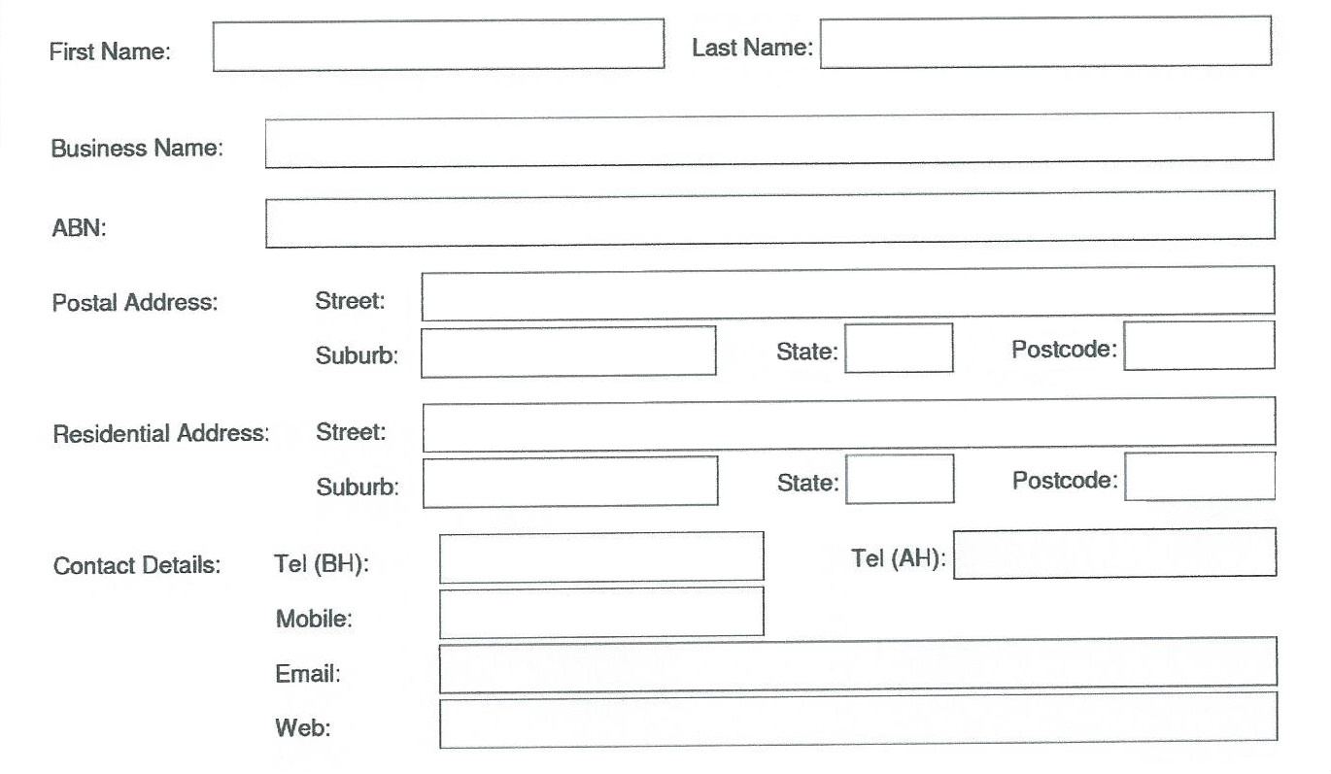

PRODUCT DETAILS:

Provide details of all the products you would like to sell on the following page.
Note that you will not be permitted to sell products that you do not list here.

Please note the following product restrictions:

No food or beverages; live birds or animals; counterfeit, copies or fakes; items associated with the illegal use of drugs may be sold.
Buskers and loud music are not permitted within the market area.
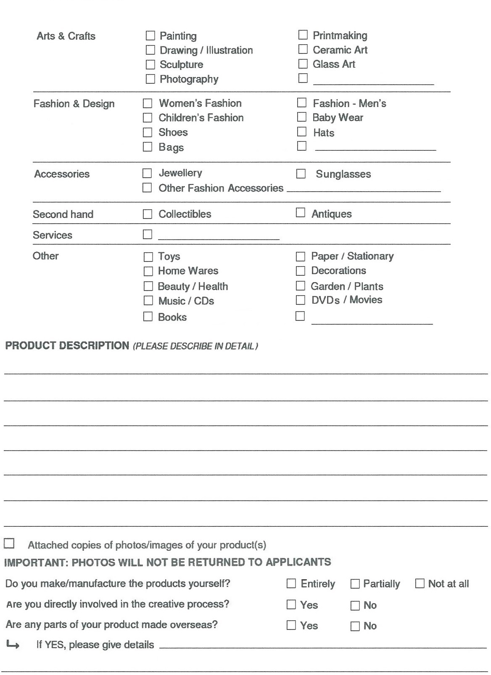
Please attach up to 2 photographs of your stall as well as photographs of all the types of products you wish to sell.

Trading hours and days:
September, October, November, March and April:
12.20 pm – 9 pm Saturdays, Sundays and all Public Holidays.
December, January and February:
12.20 pm – 9 pm Friday to Tuesday (New Years Eve trading hours start/ finish earlier - Public holidays falling on other days may incur additional costs).

Permanent stall costs:
Permanent stall holders pay for the entire trading season, in advance on a monthly basis. For the 2016 -2017 trading seasons, stall sites 8 – 18 are available at the following rates:

Sept, Oct, Nov, Mar & Apr cost $540 per month
Dec, Jan, & Feb cost $1320 per month

This works out to be approximately $60 per trading day. There are no refunds if you are unable to trade.

The above prices only include normal scheduled trading days. Should the market purchase any additional trading days from the council, participation will be optional and additional rent will be payable.

Applications will be reviewed by the Bondi Beach Community Market committee.
The decision of the committee is final.
If your application is successful you will be required to sign a contract with Bondi Beach Community Market.

I acknowledge that I have read the Bondi Beach Community Market Stallholder Terms and Conditions and agree to abide by them.
The information provided on this form is true.
I acknowledge that providing false information on this form or not abiding by the market rules may result in loss of the right to trade.

Name (print): ______________________________________________

Signature: ________________________________________________

Date: ______ / ________/ 20____

Return the completed application form with photos and email or post to the address at the top of the form.

