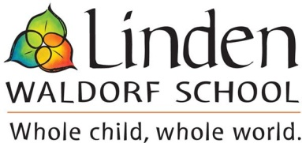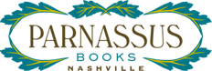
Come one, come all, to
LINDEN NIGHT AT PARNASSUS BOOKS
~ A bookish benefit for Linden Waldorf School ~
FRIDAY, DECEMBER 2, 2016
5:00 to 7:00 P.M.

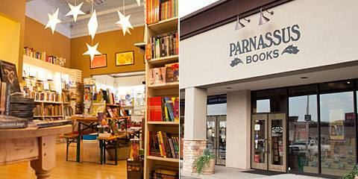

This Friday, follow the stars to locally-owned, indie bookseller Parnassus Books for a FREE celebration of books, music, and holiday shopping, all in service of the Linden Waldorf School library! Parnassus is just down the road behind Fox's Donut Den in Green Hills, 3900 Hillsboro Pike, Nashville. Ten percent of EVERY purchase rung up between 5:00 and 7:00pm will be donated to our school—what a fun way to help fund our growing children's library!
Parnassus has a wonderfully curated children's section, as well as a superb selection of literary and lifestyle books for all your holiday giving--there's something for everyone. While you're there, peruse some of the titles on the LINDEN WISH LIST and consider choosing one or two as a gift to the library or a classroom. Still not sure what you might need in the way of books? Never fear! The well-versed Parnassus staff and Linden's bookish volunteers Kate Cotton and Jennifer McCord will be on hand to help you make that perfect selection.
But, wait! There’s more! From 11:45 a.m. to 1:00 p.m., 5th graders led by class teacher Sherri Scott and music teacher Laura Duke hit the stage to share special selections played on recorder and sing songs for everyone. Come listen to these talented young musicians during this lunchtime concert! Later on, between 5:00 and 7:00 p.m., there'll be more music provided by a variety of our talented 8th graders.
So, pack up your family and friends and get yourselves down to Parnassus Books, “an independent bookstore for independent people." See you Friday!

