ODS High School Retreat
REGISTRATION
PARENTAL/GUARDIAN CONSENT FORM
LIABILITY WAIVER
February 24th – 26th, 2017
Trinity Pines Retreat Center, Colfax, CA
28000 Rollins Lake Rd, Colfax, CA 95713

Our Divine Savior, St. John’s the Baptist, St Thomas More, St Thomas the Apostle, St Dominic
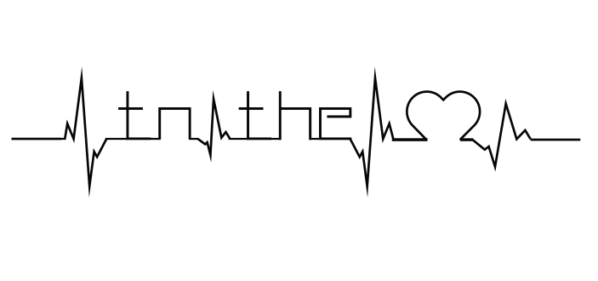
Cost: $60
Fax, mail or drop of at your parish office to:
Robert Sheridan Parish you attend:
Our Divine Savior
566 East Lassen Ave
Chico, CA 95926
odsyouthministry@yahoo.com T-shirt Size (Circle One) S, M, L, XL, 2XL
phone: 530 680-4294
Participant’s Name: ______________________________________________ ______________
Birth Date: ______ ________Gender: ______ Grade: _______School:_______________
Parent/Guardian’s Name_______________ __________________________________________
Home Address: _________ _______________________________________________________
City: Zip:
Home Phone: _______________ Cell Phone (parent):________________
Email (parent)__________

I, ______________________________ , grant permission for my child,
Parent or Guardian’s Name

to participate in this youth event. Child’s Name

